DOKUZ EYLUL UNIVERSITY

Faculty of Engineering

Electrical and Electronics Engineering

**EED 1005 Introduction to Programming Laboratoary#4**

Student Name : Yavuz BALI Number:2014502021

**Task 1:**

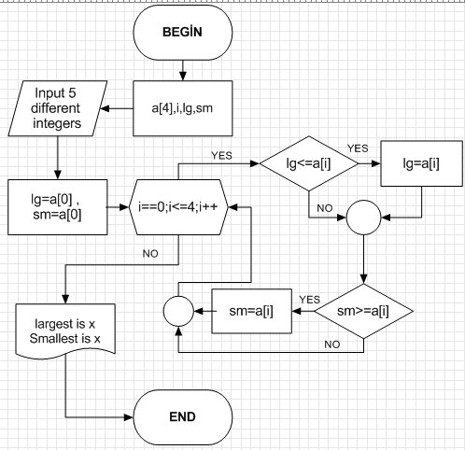

#include<stdlib.h>

#include<stdio.h>

int main()

{

int a[4],i,lg,sm;

printf("Input 5 different integers:"); scanf("%d%d%d%d%d",&a[0],&a[1],&a[2],&a[3],&a[4]);

lg=a[0]; sm=a[0];

for(i==0;i<=4;i++){

if(lg<a[i]){

lg=a[i]; }

if(sm>a[i]){

sm=a[i]; } }

printf("largest is %d\n",lg);

printf("Smallest is %d",sm);

}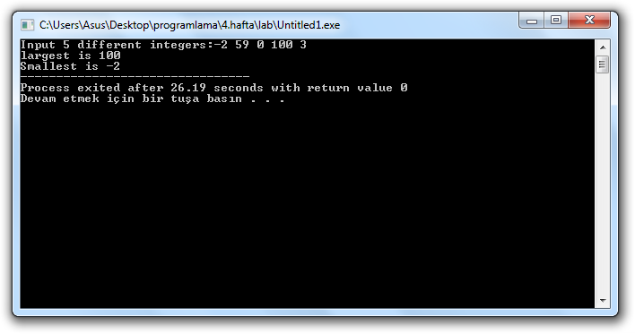

**Task 2:**

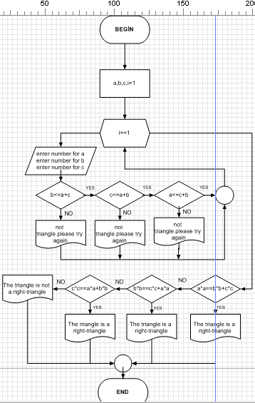

#include<stdlib.h>

#include<stdio.h>

int main()

{

int a,b,c,i=1;

while(i==1){

printf("Enter number for a:"); scanf("%d",&a);

printf("Enter number for b:"); scanf("%d",&b);

printf("Enter number for c:"); scanf("%d",&c);

if(a<=b+c)

{

if(b<=a+c)

{

if(c<=a+b)

{

i=0;

printf("The values %d,%d and %d can form the three sides of a triangle\n",a,b,c);

}

else

{

printf("The values %d,%d and %d can not form the three sides of a triangel.\nPlease try again\n",a,b,c);

}

}

else

{

printf("The values %d,%d and %d can not form the three sides of a triangel.\nPlease try again\n",a,b,c);

}

}

else

{

printf("The values %d,%d and %d can not form the three sides of a triangel.\nPlease try again\n",a,b,c);

}

}

if(b*b==a*a+c*c)

{

printf("The triangle is a right-triangle");

}

else if(a*a==c*c+b*b)

{

printf("The triangle is a right-triangle");

}

else if(c*c==b*b+a*a)

{

printf("The triangle is a right-triangle");

}

else{

printf("The triangle is not a right-triangle");

}

return 0;

}

